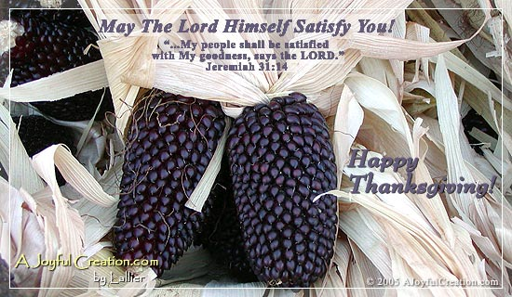

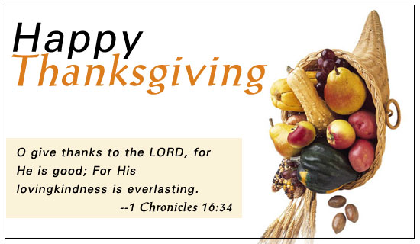

Wishing you the best of memories, peace, and joy for Thanksgiving as you think about ALL that you HAVE and ARE for which to be thankful to Almighty God.

Be sure to take advantage of the time this holiday to be with family, to fellowship, to restore relationships, and to worship and thank God for His bounty towards you.

... from Rich and friends who bring you the
Crimson & White Connection
a ministry of prayer and encouragement through FREE mailings on character, values, and the spiritual life.
and, as always, ...
Someone prayed for YOU and
mentioned you before God’s throne.
God bless and watch over you today.

for a FREE sample issue and other resources.
go to ... www.CrimsonWhite.org
or email ... RDymmel@AOL.com

Wishing you the best of memories, peace, and joy for Thanksgiving as you think about ALL that you HAVE and ARE for which to be thankful to Almighty God.

Be sure to take advantage of the time this holiday to be with family, to fellowship, to restore relationships, and to worship and thank God for His bounty towards you.

... from Rich and friends who bring you the
Crimson & White Connection
a ministry of prayer and encouragement through FREE mailings on character, values, and the spiritual life.
and, as always, ...
Someone prayed for YOU and
mentioned you before God’s throne.
God bless and watch over you today.

for a FREE sample issue and other resources.
go to ... www.CrimsonWhite.org
or email ... RDymmel@AOL.com
cc3000 ThankfulFor2.doc

For a FREE subscription to ~18 mailings a year contact: RDymmel@AOL.com or go to www.CrimsonWhite.org

Crimson & White Ministries
4401 Wild Oak Lane, Greensboro, NC 27406
You can download this card in Word or pdf formats from www.CrimsonWhite.org

C&WM mails “letters” of encouragement targeted at students, but read by all ages. Topics include character, morals, values, relationships, sex, devotional thoughts, and the Christian life. Write or email and ask for a free sample. Subscriptions are FREE after you’ve seen a sample.

cc3000 ThankfulFor2.doc

For a FREE subscription to ~18 mailings a year contact: RDymmel@AOL.com or go to www.CrimsonWhite.org

Crimson & White Ministries
4401 Wild Oak Lane, Greensboro, NC 27406
You can download this card in Word or pdf formats from www.CrimsonWhite.org

C&WM mails “letters” of encouragement targeted at students, but read by all ages. Topics include character, morals, values, relationships, sex, devotional thoughts, and the Christian life. Write or email and ask for a free sample. Subscriptions are FREE after you’ve seen a sample.

Wishing you the best of memories, peace, and joy for Thanksgiving as you think about ALL that you HAVE and ARE for which to be thankful to Almighty God.

Be sure to take advantage of the time this holiday to be with family, to fellowship, to restore relationships, and to worship and thank God for His bounty towards you.

... from Rich and friends who bring you the
Crimson & White Connection
a ministry of prayer and encouragement through FREE mailings on character, values, and the spiritual life.
and, as always, ...
Someone prayed for YOU and
mentioned you before God’s throne.
God bless and watch over you today.

for a FREE sample issue and other resources.
go to ... www.CrimsonWhite.org
or email ... RDymmel@AOL.com

Wishing you the best of memories, peace, and joy for Thanksgiving as you think about ALL that you HAVE and ARE for which to be thankful to Almighty God.

Be sure to take advantage of the time this holiday to be with family, to fellowship, to restore relationships, and to worship and thank God for His bounty towards you.

... from Rich and friends who bring you the
Crimson & White Connection
a ministry of prayer and encouragement through FREE mailings on character, values, and the spiritual life.
and, as always, ...
Someone prayed for YOU and
mentioned you before God’s throne.
God bless and watch over you today.

for a FREE sample issue and other resources.
go to ... www.CrimsonWhite.org
or email ... RDymmel@AOL.com
cc3000 ThankfulFor2.doc

For a FREE subscription to ~18 mailings a year contact: RDymmel@AOL.com or go to www.CrimsonWhite.org

Crimson & White Ministries
4401 Wild Oak Lane, Greensboro, NC 27406
You can download this card in Word or pdf formats from www.CrimsonWhite.org

C&WM mails “letters” of encouragement targeted at students, but read by all ages. Topics include character, morals, values, relationships, sex, devotional thoughts, and the Christian life. Write or email and ask for a free sample. Subscriptions are FREE after you’ve seen a sample.

cc3000 ThankfulFor2.doc

For a FREE subscription to ~18 mailings a year contact: RDymmel@AOL.com or go to www.CrimsonWhite.org

Crimson & White Ministries
4401 Wild Oak Lane, Greensboro, NC 27406
You can download this card in Word or pdf formats from www.CrimsonWhite.org

C&WM mails “letters” of encouragement targeted at students, but read by all ages. Topics include character, morals, values, relationships, sex, devotional thoughts, and the Christian life. Write or email and ask for a free sample. Subscriptions are FREE after you’ve seen a sample.

